Fall 2019
Instructional Program Review
Music, Physical Education/Athletic Training, Echocardiology, HVAC

Spring 2020
Instructional Program Review
Education, Industrial Maintenance
Summer Programs: Biology & Welding

Phase 1: Data Collection
Owner: Office of Institutional Effectiveness (OIE)
For each program review, data will be available to the program via the Program Dashboard located on the Institutional Effectiveness Website at https://www.hillcollege.edu/About/IRE/IE-Reports.html. Data includes student enrollment, course, success and graduation data. For workforce/technical programs, each program will be given Perkins Grant information and labor market information. The data provided is assist the program in completing the Program Review Questionnaire.
Timeline: 1 Month

Phase 2: Instructional Review Orientation & Questionnaire Development
Owner: Instructional Program
Each instructional program will receive a Program Review Questionnaire. Programs will complete this questionnaire using data provided by OIE, data from other agencies or accreditation boards that pertains to the program and activities within the program. In order to fully complete the questionnaire, programs may need to review data/information from external agencies or other reviews that are directly connected to the program (Example- State Board of Nursing for nursing programs). The questionnaire should reflect current activities in the program as well as future needs. Program faculty both full time and adjuncts should actively participate in the instructional review process.
Communicate with Program Coordinators and Instructional Deans throughout this phase. Make sure to communicate with the OIE on any issues found or questions about the process or questionnaire.
Timeline: 1 Month
Questionnaire Development
The questionnaire is the most important part of the process. The questionnaire responses will help to determine the goals and task going forward with each plan. The responses also help OIE determine who will be in attendance for the compression planning sessions.
Questionnaire Completion
Data Review-
- Institutional Data-
  - The OIE has developed a dashboard of institutional data. Data reflects several years prior. Analyze the data to determine trends and opportunities for the program.
  - Student Learning Outcomes-SLO data should be reviewed during this process. Review action items and discuss in the questionnaire how the program will accomplish these tasks.

- External Data- Each program may use data from other agencies that show an impact to the program. This could be passing rates for licensure programs, standards that determine external accreditation specific to the program, transfer information, graduation and/or persistence information.
- Workforce Data- Each program may want to use data elements from employment information. This type of data can help programs explain viability for the program as well as future opportunities for expansion and/or change.
- CTE Programs- Review of Perkins Grant measures. A dashboard of Perkins Measures is available to show how CTE programs are performing. Discussion on the questionnaire should reflect activities the program engages in to meet specific measures.
Programs should reflect on the data and other items of importance to complete the questionnaire. If data is provided from another source beyond institutional data, please site where the information was derived.
Instructional Program Data Dashboard
The data dashboard has been developed using institutional data that will be updated each year. Data has been reviewed for accuracy, but each program should review the information for accuracy. Any questions about any of the data dashboard pages should be directed to the Office of Institutional Effectiveness.
Navigation
- Select the specific program to review at the top right of each page. A dropdown menu will appear and select a program by clicking the box.
- Program Dashboard has four pages. Navigate from page to page by click on the at the bottom of the page
- Each chart/graph can be expanded by clicking on the icon at the top right of each graph. This will take you to a larger visual of the chart/graphic. Right clicking on this page will give you a show data option. A chart will appear below the graphic to see information in a table format. Select the to navigate by to the dashboard page.
- Each chart/graphic is equipped with hover capability. Data information can be seen by hovering over a graphic.
- Larger tables will have slide bars on the right-hand side.
- Several charts are College-wide charts to allow each program to compare their program to the college as a whole.

NEW Instructional Program HUB

This document is provided to assist programs in access the Instructional Program Review hub. If you have any questions, please contact Sherry Davis at shdavis@hillcollege.edu or 254-659-7818.

Training on the hub can be provided.

- Attend the Instructional Program Review Orientation
- Access Microsoft Teams-digital hub for all documents and tracking regarding instructional institutional effectiveness processes.
  - Do you have a Microsoft 365 account through Hill College?
Yes, I have a Microsoft 365 Account | No, I don’t have a Microsoft 365 Account
- An email is sent to invite you to Microsoft Teams  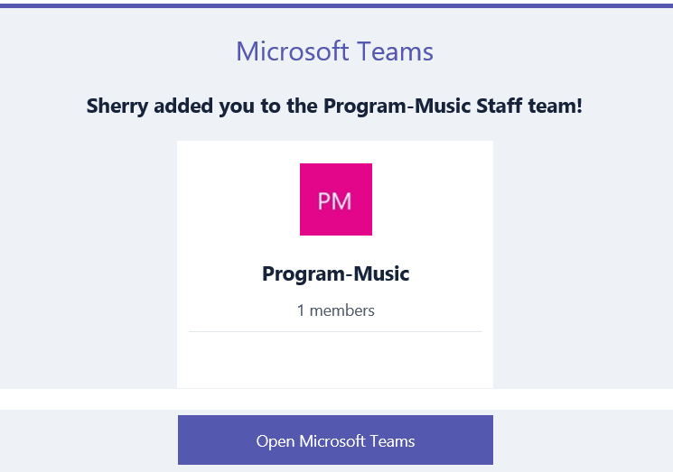  Click Open Microsoft Teams  - The next screen will inquire as to which way to access Teams. (1) Download the App to your computer, phone or tablet or (2) access through the web.  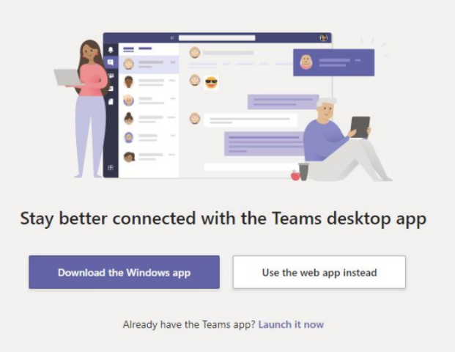  - Login in using your Microsoft 365 login. This is not the same as your Hill College login. | - Set up a Microsoft 365 Account.  - Hill College has enrolled in the Office 365 Education program that allows access to Office products plus other collaboration apps. The plan allows you to use on up to 5 devices.  - Click on Office.com/GetOffice365.  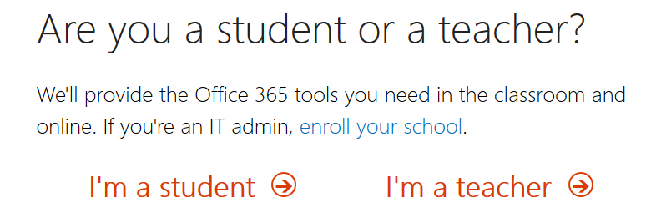  - Select I’m a teacher and follow the prompts to set up your account.  - Click through to download & sign in with your credentials (Enter your Hill College email address and click "Sign up". Once you receive your confirmation email, sign in with your Hill College email address, and download.  NOTE: If you do not receive your confirmation email, be sure to check your junk/spam folder).  IMPORTANT: Notify the Office of Institutional Effectiveness (Sherry Davis) so that you can be added to a Team account.  - The download site, select your language and click install  NOTE: You will need your school email account to sign in. If you don’t have your login information or have trouble, submit a help request to the IT department.  For Mobile Devices:  You can download from your App Store.  - Follow the Yes, I have a Microsoft 365 Account to access Microsoft Teams
- Microsoft Teams: Click on your Team Icon

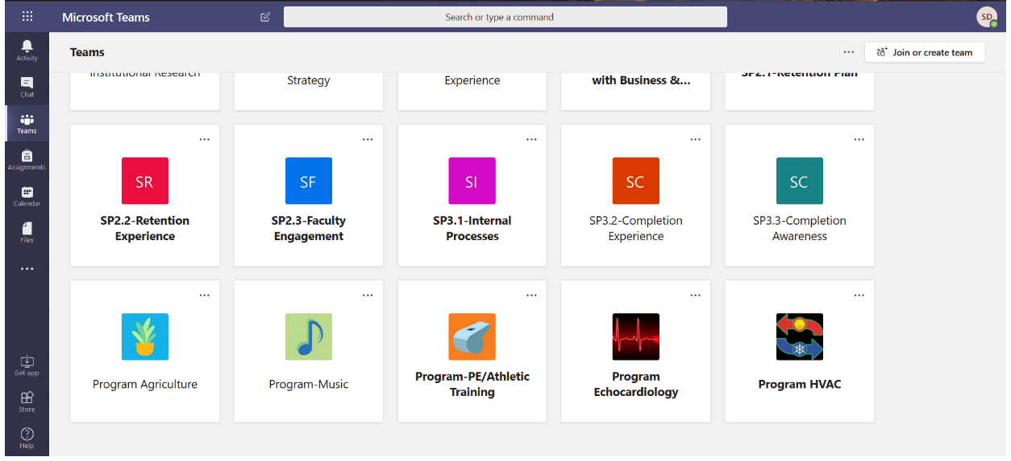
- Team Page

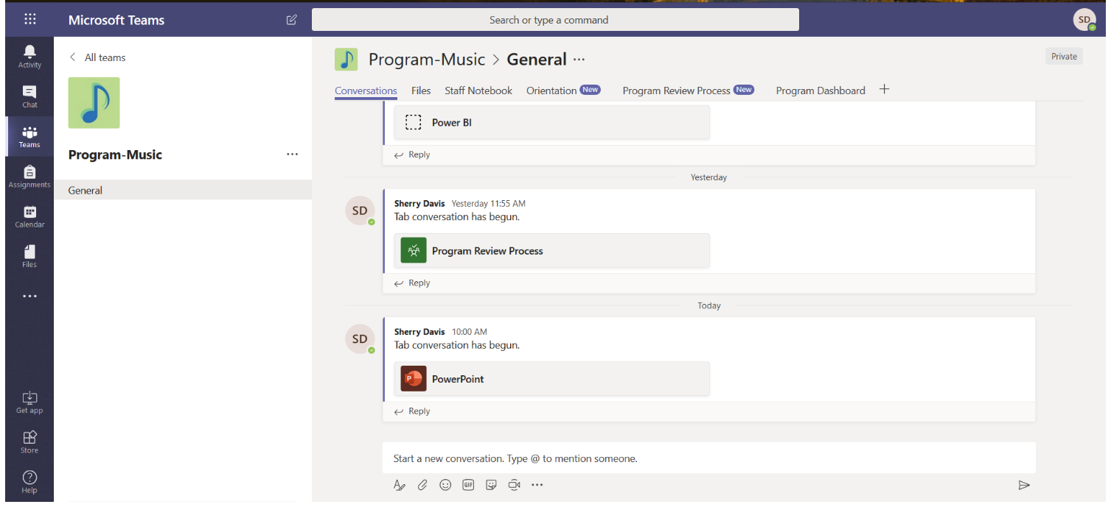

Conversations: Each member of the group can post comments or information. Conversations are like social media type frames.

Files: The Office of Institutional Effectiveness uploads documents pertaining to the program review. Additional documents can be loaded to the file area. In order to create a tab using a document, the document must be preloaded into the file tab.

Staff Notebook: This can be used to store program research or information compiled by group members.

Orientation: The Office of Institutional Effectiveness loads the Orientation PowerPoint for a resource to the program.

Program Review Process: This is a planning tool that can be used by the program to keep track of task and deadlines. To do items can be added as needed.

Program Dashboard: This page will link the group to the program data dashboards for institutional data about the program. Dashboard provide data on student demographics, course enrollments, course success rates, graduation and scheduling/sequencing of courses.

Questionnaire (Initial Review): Is is the document that must be completed prior to compression planning sessions. The document can be collaboratively worked on by multiple faculty if Coordinators so choose.

Initial Program Review: The Office of Institutional Effectiveness will post the final draft of the program review after approvals are received. Programs can refer back to the document as needed.

Annual Follow-up: The Office of Institutional Effectiveness post the active excel document for annual follow-up of task for programs to complete. The program has access to this as soon as the Program Review is final. Programs can updated task, delete or add task throughout the year.

Phase 3: Review & Preparation for Compression Planning Sessions (CPS)
Owner: Office of Institutional Effectiveness (OIE)
Once the Program Review Questionnaire is completed, the questionnaire along with any attached documentation will be reviewed. During this review, the owners will make strides to determine any trends or possible “talking points” based on the information provided. The Office of Institutional Effectiveness will seek out clarification if needed. The OIE will plan the compression meeting as well as invite cross-functional staff and faculty to assist in the plan development.
Determine compression planning attendance based on questionnaire results.
Timeline: 2 Weeks

Phase 4: Compression Planning Session (CPS)
Owners: Instructional Program & Cross-functional areas
Facilitators: External Affairs & Office of Institutional Effectiveness (OIE)

The CPS will be a face to face session that will last approximately 4 hours. The session will consist of selected program faculty and cross-functional departments. Cross-functional department attendance will be determined during Phase 3 based on information in the questionnaire. Attendance to the session is specific to each programs needs and trends determined during Phase 3. During the CPS, all areas will open communication based on results derived from Phase 3. The session goal is to determine goals/objectives as well as create an action plan for the program.
The CPS is a visual group process designed to bring out a group’s best thinking and energy to resolve complex issues in an environment of fair play and equal participation led by a facilitator. Compression planning gets everybody heading in the same direction and compresses the planning time for major projects to enable your programs to achieve the result you need.
Timeline: 4 hour session (approximately)

Phase 5: Action Plan Review & Annual Review Process
Owners: Instructional Program, Dean of Instruction, Vice President of Instruction, Institutional Effectiveness Committee (IE)
Facilitators: External Affairs and Office of Institutional Effectiveness
After the CPS session, the action report will be forwarded for review to the Dean of Instruction over the program and the Vice President of Instruction. Each of these areas will be able to make any comments as well as discuss outcomes with the program. Once all of the Instructional Division has reviewed the action report, the final document will be sent to the IE Committee. Annually, an update document will be sent submitted to the IE Committee on the status of the action plan. Each program review will be based on a 3 to 5 year rotation.
Timeline: 1 Month

Annual Follow-up Instructions

The Instructional Program Review Annual Follow-up is documented in the attached Excel workbook. The follow-up consists of several Excel tabs. The workbook is updated annually by the Program Coordinator or designee.
PROGRAM REVIEW PROCESS NOTES
Cycle: 2019-2020 only- Follow-up forms will be submitted twice once in August and January due to finding from the Institutional Effectiveness Committee review of the process. Going forward, Program Review Annual Follow-ups will be due in January.
Task Updates: Task for this plan are expected to be updated as progress is made, task removed as research or needs become obsolete, or added to as new items should come from current task work.
Communication: It is up to the program faculty to communicate together about the specifics of current task, future task, removal of task, etc. Instructional programs should be working through current task as well as documenting in the follow-up new task or directions in which the program will be going as a result of research and information. Programs should assign task to program faculty as needed. It is also important to have regular communication with Instructional Deans about program review as well as continuous communication throughout the year with program faculty about the progress of the plan.
Timelines: Timelines should be realistically set to the specific task and level of involvement. More time should be set for thing that require meetings or others to help make decisions. Always remember that task that require budgetary items should follow a timeline pertain into the opening of the next year’s budget (January to March)..
Budgetary Items: Some activities within the program review may require funds. Budget cycle typically begins in January. This is the time in which the programs should put in request pertaining to their program review. Please make sure to denote that the item is related to continues progress on the plan.

COMPLETING THE ANNUAL FOLLOW-UP
- Tab 1: Objective Dashboard.
  - This tab doesn’t require any updates.
  - This tab is updated by the Office of Institutional Effectiveness after the program has submitted the final information.

- Strategy Tabs (Yellow Tabs)
  - Each plan is has a different amount of tabs depending on each strategy in the individual plan
  - Each tab needs to be updated.
    - Step 1- Update current task
      - Update the Task Status (Use the dropdown menu to select the status)
      - Update the Grayed Columns
        - Task % Completed: Increments of 25%. If completed, select 100% and make sure the put in the date completed.
        - Date Completed: Put in the date that specific task was completed. Task % should be 100%.
        - Assessment Results- This is be narrative describing what was determined based on the task. This narrative should tie to the task written.
        - Use of Results: Using results of the task, place in narrative of if it led to different focuses, does it lead to improvements to be used in the future, and/or does it accomplish the overall goals.
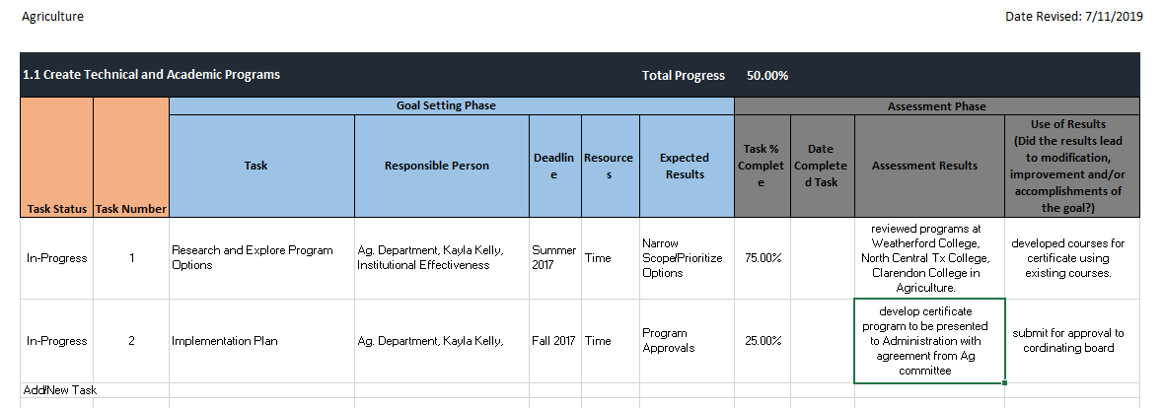
      - Note: If deleting a task or placing one on hold, the program must complete the assessment results to explain why the program has elected to delete a task or placed a task on hold.

    - Step 2-Add New Task
      - Programs are expected to continue to add new task as other task are completed. This process is on-going for the programs
      - Task Status-Make sure to select the option from the drop-down box.
      - Task Number- Only whole numbers should be entered.
      - Goal Setting Phase (Blue Headings)
        - Task- Explanation of what this specific item requires. For good measure, keep it simple, but descriptive.
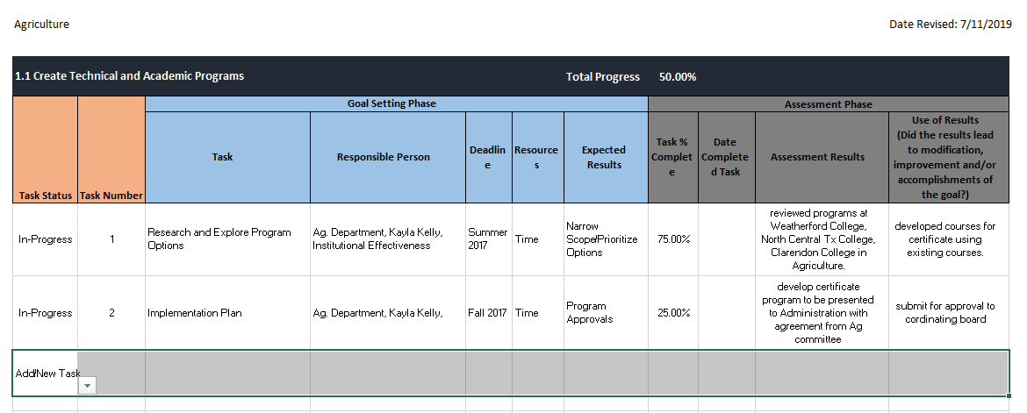
        - Responsible Person(s)-Select the stakeholders for this task. Depending on the task it could be the whole department as well as other areas of the college or community. Be specific when needed.
        - Deadline: Task should have an end date. If not, go back and break down the task into smaller parts/steps. Give a reasonable amount of time knowing the amount of time or how many stakeholders are involved to get the task complete.
        - Recourses: Many times task require time and human capital versus funds. If money is involved, try to put a dollar amount to the item. If not, a range might be a better option. Placing a targeted amount in the field will help during budget times to estimate cost.
        - Expected Results: This column answers what does the program expect when the task is completed. Does it require another step? Does it increase enrollment, retention, completion?
      - Assessment Phase (Grey Headers)
        - This section would be completed in the next follow-up unless the actual task entered has been completed.

- Process
  - Excel spreadsheets are email to Office of Institutional Effectiveness
    - Sherry Davis, shdavis@hillcollege.edu or
    - Gabby Smith gsmith@hillcollege.edu
  - Deadline January 30
  - What’s Next
    - Office of Institutional Effectiveness
      - Reviews the follow-up document and will contact program coordinators to discuss any questions, updates and/or changes.
      - Update of the Objective Dashboard
        - Percentages will be reviewed for accuracy
        - Notes added to explain changes or updated, if needed
      - Finalized document is created and sent to Instructional Deans and Program Coordinators
    - Instructional Programs
      - Action in the plan by completing task and creating new task to meet the objective.
      - Communication within the department about task and forward progress
      - Communication with Deans of Instruction about plan progress
      - Communication with the Office of Institutional Effectiveness, if assistance is needed.

